Date: 05.09.2025

To,  
Mr. Veeresh   
Hyderabad.

**Sub: Internship offer**

Dear Veeresh,  
  
With reference to your interview with us dated 24th August, 2025, we are pleased to offer you the Internship of **“Node Js Developer**” During this internship, you are going to be reporting to the Sr. Developer.  
  
It will be a paid internship program for one month, with a stipend of INR 5,000 . to help you advance your knowledge and abilities under the supervision of professionals, with the following terms & conditions:-

* Your work schedule isfrom Monday-Saturday from 9:30 am to 6:30 pm. However, the nature of work may require some variation and extension of days or time.
* Each intern is required to put in at least eight hours of work per day. In case of late entry he/she is required to stay back & complete 8 hours of work excluding break.
* You are allowed to take a total of 6 leaves (3 CL + 3 SL) in a three-month period, with the prior approval of your reporting manager  
  .
* Emergency leaves can only be availed if an intern is unable to attend work due to some accident, illness or injury occurred to his/her immediate (blood relation) family member and should notify his/her manager as soon as possible.
* There will be direct termination of the internship when you consistently three or more days of work without notification.

This internship is initially offered for **1 month**. Based on your performance during this period, you may be:

* Onboarded as a **full-time employee**, or
* Your internship may be **extended further** for evaluation.

If at any point during the internship, your performance is found to be unsatisfactory, the company reserves the right to discontinue your internship.

This internship is valid only for a total duration of **3 months**, and upon successful completion, you will be awarded a certificate.

During the course of your internship, you may have access to confidential information and trade secrets of **Ozrit**. By signing this offer, you agree to keep such information strictly confidential and not use it for personal gain or disclose it to any external parties. Any breach of this condition will authorize the company to take necessary actions as required.

.   
At the end of your internship, you also agree to return any equipment, documents or other company property issued to you by the **OZRIT**

Your acceptance to this offer shows your acknowledgement of the fact that this is not an offer for full-time employment and it does not guarantee a job offer upon completion.

Kindly submit your Aadhaar, PAN and Highest qualification certificate copy on the date of your joining.

Kindly confirm your acceptance of the letter by signing and returning to us the attached duplicate copy of this letter.

***Welcome on-board!***

**Best Regards**

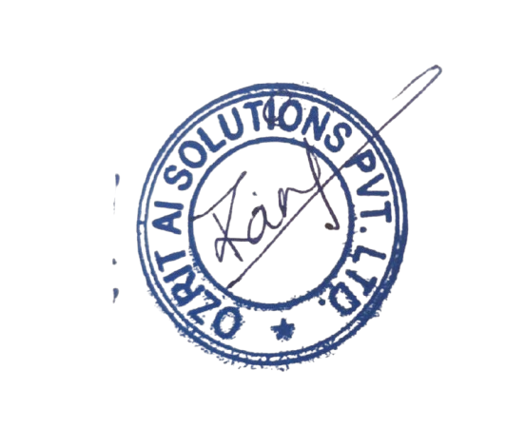

Rani Kumari

HR & Admin Executive

I accept this letter and above terms and conditions.   
  
Veeresh